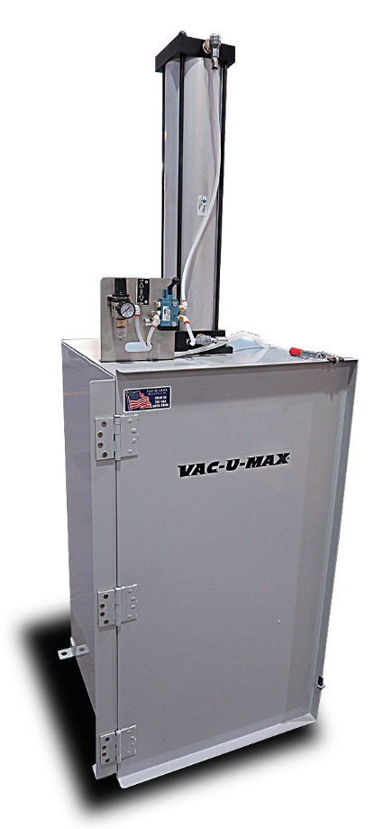

PROPOSAL NO. 01-(Quote Number)

DATE: May 13, 2016

(Customer Contact Info)

Dear (Salutation)(Last Name),

Thank you for your interest in the VAC-U-MAX Bag Compactor.

The Bag Compactor is complete with:

* Heavy duty construction,
* Hinged door
* Non-defeat able switch interlocked with door to prevent air cylinder drift,
* All pneumatic operation with low air consumption.
* Dust collection port

The VAC-U-MAX Bag Compactor is available in Carbon Steel with a food grade powder coated finish, stainless steel with a bead blast finish.

Best Regards,

(Opportunity Owner)

VAC-U-MAX

**Attachment A**

|  |  |  |  |  |
| --- | --- | --- | --- | --- |
| Item | Qty | Part Number | Description | |
|  |  |  |  | |
| 1 | 1 | 63958CS/06 | VAC-U-MAX Stand Alone Empty Bag Compactor with the following features: | |
|  |  |  | * Pneumatically operated for general purpose and explosion hazard areas * All pneumatic controls, no electrical requirements * 1,700 pounds of force @ 60-80 PSI of compressed air * Low Compressed Air Requirement (4.3CFM PER CYCLE=EXTEND & RETRACT) * Full Width Front Unloading Door | |
|  |  |  | * Safety interlock halts operation if door opened * Large Volume Pneumatic Ram Actuator (carbon steel unit with aluminum/carbon steel(epoxy coated)cylinder) | |
|  |  |  | * Compacts 50 to 150 bags (depending upon size of bags) * Waste Bag Support Frame * Four angle feet for lagging to floor * Four inch dust collector connection on top rear of unit | |
|  |  |  | * Heavy Duty Construction, Carbon Steel | |
|  |  |  | * Finish: Painted Pearl Gray. * Roll of 50 plastic bags (Part Number 19440/02) included | |
|  |  |  |  | |
| Selling Price for 63958CS/06 | | | | $ 8750.00 |
| Selling Price for 304 Stainless Steel construction P/N 63958SS/06 | | | | $ 9750.00 |
| 19440/02 | | Bag, Plastic 3 Mil, 30” X 26 X 60” 50 PCS | | $ 215.00 ea |
|  | |  | |  |
| 63958SS/07 | | All Stainless Steel Constructed Bag Compactor with Stainless Steel Air Cylinder | | $11,750.00 |
| 63958CS/06DD/D | | All Carbon Steel Constructed Bag Compactor with drop down front door | | $9250.00 |
| 63958SS/06DD/D | | Stainless Steel Constructed Bag Compactor with standard air cylinder and drop down front door | | $10,500.00 |

**Payment Terms:** Net 30 days from invoice date, subject to credit approval

**Delivery Point:** EX-WORKS (INCOTERMS 2010) Belleville, NJ, USA.

**Duration of Proposal:** Prices are firm for 60 days and subject to review thereafter.

**Certified Drawings:** One (1) week after receipt of order by VAC-U-MAX.

**Shipment of Equipment:** Four weeks (after order entry).

* This proposal is rendered subject to the terms and conditions on Form #11003 5/99 attached
* Price exclude federal, state, or local taxes

